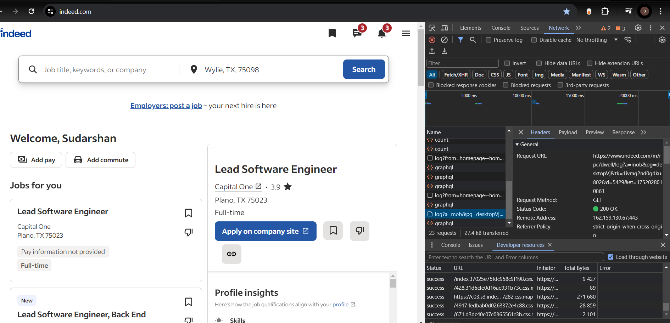

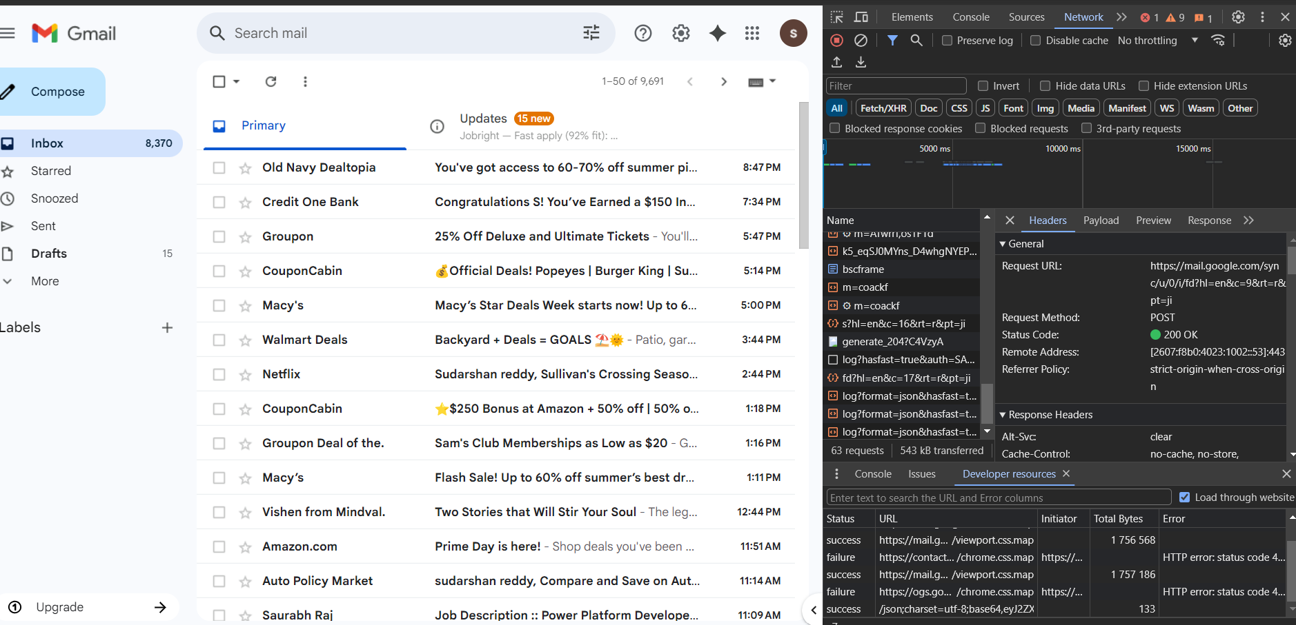

**3. C. What type of requests did you notice? (Look at the Method column – GET, POST, etc.)**

i) Indeed – Post method-Plain/text

ii)Indeed -Get method-Text/html

iii)Gmail-Get method- Image/gif

iv)Gmail-Post method-Text/plain

**5. E. Was it JSON, HTML, or something else?**

In both cases, the responses were in JSON format, commonly used for APIs due to its lightweight structure.

**Write a small JavaScript program to simulate sending an HTTP request using fetch():**

javascript

CopyEdit

fetch('https://jsonplaceholder.typicode.com/posts/1')

.then(response => response.json())

.then(data => {

console.log('Title:', data.title);

console.log('Body:', data.body);

})

.catch(error => console.error('Error:', error));

**What are the 4 main parts of an HTTP request?**

1. **Request Line** – Method (GET, POST), URL, and HTTP version.
2. **Headers** – Key-value pairs that carry additional information about the request.
3. **Body** – Data sent with the request (usually in POST/PUT).
4. **Method** – The type of action to perform (GET, POST, PUT, DELETE).

**What do these headers mean?**

* **User-Agent:** Identifies the client making the request (e.g., browser type/version).
* **Accept:** Specifies the content types (e.g., application/json, text/html) the client can handle.
* **Host:** Indicates the domain name of the server (e.g., example.com).
* **Write a sample HTTP request to example.com/about using the GET method in raw format:**

GET /about HTTP/1.1

Host: github.com

User-Agent: Mozilla/5.0 (Macintosh; Intel Mac OS X 10_15_7)

Accept: text/html,application/xhtml+xml,application/xml;q=0.9

Connection: keep-alive

**Use** [**https://jsonplaceholder.typicode.com/**](https://jsonplaceholder.typicode.com/) **to:**

**1. Fetch a post and show its title and body in the console**

javascript

CopyEdit

fetch('https://jsonplaceholder.typicode.com/posts/1')

.then(response => response.json())

.then(post => {

console.log('Title:', post.title);

console.log('Body:', post.body);

});

**2. Fetch and display comments for post ID 1**

javascript

CopyEdit

fetch('https://jsonplaceholder.typicode.com/posts/1/comments')

.then(response => response.json())

.then(comments => {

comments.forEach(comment => {

console.log(`Name: ${comment.name}`);

console.log(`Comment: ${comment.body}`);

console.log('-------------------------');

});

});